Kanoya Future Creation Program - Bouquet of Peace 2024
Message for Peace" Application Guidelines"

Kanoya Future Creation Program
Executive Committee of "Bouquet of Peace"
(Secretariat: Kanoya City Board of Education)

1 Purpose
To provide an opportunity to think about peace and human rights by sending messages for
peace from Kanoya to children and students who wish for the world peace.

2 Main Sponsor
Kanoya Future Creation Program "Bouquet of Peace" Executive Committee

3 Co-Sponsors
"Sora ga Tsunagu Machi Hito Zukuri" Promotion Council (Usa City, Kasai City, Himeji
City, Kanoya City)

4 Sponsors
Kagoshima Prefectural Board of Education, Minami-Nihon Newspaer, Minami-Kyushu
Newspaper, Kumamoto Nichinichi Newspaper, Miyazaki Nichinichi Newspaper, Oita
Godo Newspaper, NHK Kagoshima Broadcasting Station, MBC Minami-Nihon
Broadcasting KTS, Kagoshima TV KKB Kagoshima Broadcasting KYT, Kagoshima
Yomiuri TV

5 Call for Works
⑴ Details of Application
Messages with the theme of "Peace" (English)

【Examples】
"My Idea of Peace" "Baton Pass to the Future" "The Happiness of Everyday Life"
"This Happiness Must Not Be Lost in an Instant" "The Happiness of Everyday Life"
"I hope this happiness will not disappear in a moment." "From my grandparents' war
experience." "Visiting War Ruins" "How to Understand Peace" "Human Nature" etc.

⑵ Entry Categories
"Message for Peace" English section
〇 A4-size free-form paper (portrait, landscape)
〇 Within 2 Pages (about 500 words)
〇 The First Line: the Title
〇 The Second Line: the School Name
〇 The Third Line: Grade and Name
〇 From the fourth line: the Main Text…

⑶ Prizes, etc.
〇 Each school is required to send Two Excellent Works among them.
〇 In the "Message for Peace" English language division, One Grand Prize Winner and
Two Excellence Award Winners will receive a Certificate and an Additional Prize
(stationary… etc.).
〇 The Grand Prize Winner will be invited to Japan with his/her 1 parent or 1 Teacher
(Total 2 Persons).
〇 Homestay: Departure: July. 29 Return: July. 31
※ We’ll tell you Details later. ※ We can change the date of tickets to return.

⑷ Selection Method
〇 Choose Two Works based on judging of each school in Taiwan.
〇 A final judging will be held and the Grand Prize Winner and Two Excellence
Awards Winners will be decided by the selection committee Members in Kanoya
City.

⑸ Handling of Works
〇 The copyright of the works belongs to the organizer.
〇 The Sent works will not be returned.

⑹ Entry Method
〇 Two Works per One School must be submitted.
〇 Each school is required to prepare a separate "Application Form" and send it by e-
mail.
※ On the application form, please indicate the two works chosen by each school in
Taiwan and the total number of works (all members known about this contest
in your school) submitted by each school in Taiwan.

⑺ Application period
Friday, June 7, 2024 ※ must be received

⑻ Application and Inquiries
Kagoshima Prefectural Kanoya City Board of Education, School Education Division
Secretariat of "Bouquet of Peace", Kanoya Future Creation Program.

Postal code: 893-8501
Address: 20-1 Kyoei-cho, Kanoya City, Kagoshima Prefecture
TEL: 0994-31-1137

⇒⇒ Ｅ－ｍａｉｌ ： ｍ．ｙａｍａｕｃｈｉ＠ｃｉｔｙ．ｋａｎｏｙａ．ｌｇ．ｊｐ

- To Kanoya City BOE by June 7

Kanoya Future Creation Program - Bouquet of Peace 2024-

"Messages for Peace" Application Form

【School Information etc..】
School
Name
School
Address
Teacher’s Name |  | E-mail

【English Section】
The total number of works
※ Fill in the Total Number of this contest known in your school.
※ We hope many students of each school in Taiwan will try this program.
If all students (ES / JHS / HS) know this contest, please write the Total Number of your
school.

【List of Applicants' names】
No. | Chinese Name  English Name | Grade | Title
1
2
※ Fill in the two representative students’ name, grade and title chosen by each school in
Taiwan.

- To Kanoya City BOE by June 7
Title
School Name
Name

Within 500 words (Format is free, but A4) ※ Dead Line June 7

Example in 2021

Human Nature

Masato Komura

Hello, everyone. Today, I would like to talk about my opinion about the world. I like this world. And I like my family and friends. I like them, but I wouldn’t like them if they were the only ones in this world. I like them because I miraculously met them out of billions of people in this wide world. It is only because of this world that so many miracles can happen. So, I love this world and wish for eternal peace.

Then, what exactly is peace? Many people say that the opposite of peace is war. But is it really so? If there is no war, is there peace in this world. Is there really peace in a world that is full of racism and social violence? I still don’t believe that this world is peaceful. In the beginning, I said, “I like them because they miraculously met me in this wide world.” It is you, no one else, who makes me feel the miracle of meeting. So for me, people from all over the world, whom I have never met face to face, are the people I should be grateful to, the people who are important to me. I don’t wait those people to do anything to hurt each other. I want them to take care of each other. Discrimination is caused by judging differences between groups more than differences in groups. However, I believe that racial differences are only on the outside, in terms of appearance and culture, but on the inside, in essence, we are all the same. A man named Frank Sinatra said, “If you don’t know the guy on the other side of the world, love him anyway because he’s just like you. He has the same dreams, the same hopes and fears. It’s one world, pal. We’re all neighbors.” This is the essence of what I’m saying. As we move forward with our dreams, hopes and goals in our daily lives, we stumble, worry and move forward again. We may be different races, but we are all the same. So, let’s stop discriminating. Instead of focusing on our differences. Let’s look for the same things and coexist. Why are people so obsessed with their differences? I think it is because they are afraid. They are afraid of things that are right, and I think somewhere in their hearts they have that feeling. In such a case, we need to help each other, and when you are close to someone you can trust, your little fears will disappear. People are all the same, and differences don’t make you wrong, let’s say goodbye to our timid selves. The human heart is strong. The more friends you have, the stronger you become. The current state of the world is that we use this strength of the group for bad things such as discriminatory behavior. From now on, however, let’s use the strength of the group for goodness. We can do it because there is no such thing as a person who doesn’t have a shred of kindness in them.

Let’s take care of the people around us first. Then, let’s be grateful to strangers somewhere in the distance. We are the ones who make this world go round. Let’s create a world without discrimination and take another step toward a peaceful world.

Example in 2022
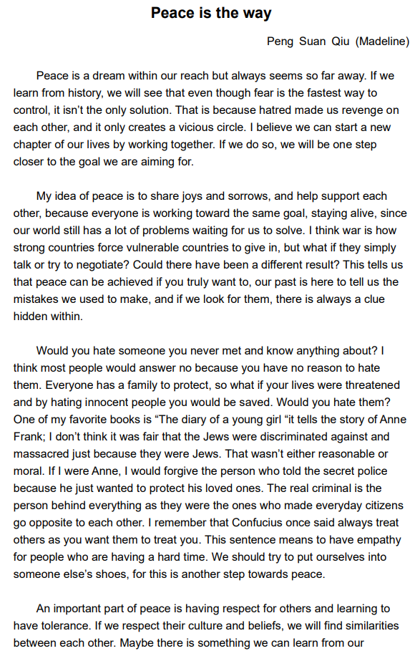

NTUEEES

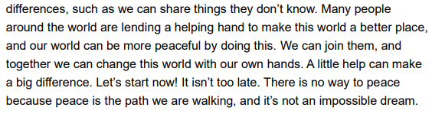

Example in 2023

※From this year, 1st prize student and parent or teacher are invited to Kanoya City, but because
of bad weather we didn’t accept them. We are waiting for 2024 new challenge.

Why I believe Peace is the only way to a better future!

Chung Dau Elementary School Fourth grade,
Sean Chen

Time goes back to May 31, 1945, in Taipei. There was a young man named Haru who had just collected duck eggs from the banks of the Keelung River at Duck Village. He intended to sell them at the market in exchange for daily necessities. While walking halfway, the air raid alarm suddenly sounded, startling him. With the duck eggs in his hands, he panicked and began to run. As the sound of explosions grew nearer, suddenly there was a loud bang beside him, causing him to lose his balance for a moment. The duck eggs he was carrying rolled and broke, leaving a mess on the ground. Despite feeling disheartened, he didn't have time to clean up and continued running towards the nearest shelter.

After the air raid finally ended, he made his way to the market with heavy steps. He only had some loose change in his pocket, barely enough to buy some rice to bring home. At that moment, a friend at the market noticed him and immediately reached out to take off her own hat, exclaiming, "Haru, why are you wearing a torn hat?!" Haru glanced at the hat his friend held, only to see a palm-sized tear on the crown. He was both astonished and frightened. Images flashed in his mind, of fragments from the explosion swiftly passing just above his head. The fragments were so fast and sharp that they tore through the hat, yet it still remained securely on his head. Overwhelmed with the realization of his narrow escape,
he couldn't help but burst into tears.

This young man named Haru is actually my great-grandfather. When my grandmother told me this story, I couldn't help but think that if that shell had deviated a few centimeters,
I wouldn't have had the opportunity to come into this world and share this story with
everyone. War is cruel in this way. Death can strike anyone at any moment. When a life is extinguished, all the subsequent lives and the possibilities of a better future vanish as well.

World peace is not just an inspiring vision for humanity. It represents the replacement of conflict and violence with cooperation and understanding. On the contrary, war is the most violent means, and even when it ends, it may create more problems and leave more tragic
memories in the hearts of people, requiring more time to heal.

Each one of us can contribute to promoting world peace. Open communication and sincere understanding of each other can bridge the gaps between different cultures, ideologies, and interests, fostering peaceful coexistence and ensuring the opportunity for the sustainable development of our planet for future generations. Let us remember the sacrifices of those who lived through wars, and strive for a world where peace prevails, ensuring a future where stories of my great-grandfather, Haru, can be shared in a world of harmony.
